# **Section 1 – Introduction**

I have focused on *learning* as my topic. I concentrated on following interconnected topics of university classroom learning -

1. Teaching and learning methods
2. In class note making
3. Discussion Collaborative tools – Piazza/Google Drive

Although of tremendous interest, topics require long studies and diary studies. Given the scope of the class and timelines, I have collected photos pertaining (3) i.e. Piazza

# **Section 2 – Observations**

Since, I am interested in redesigning university student experience, I interviewed students at UCSD. My observations around habits of learning for three interviews are as follows

**2.1 Kaila**

Kaila is a sophomore COGS major. Her favorite class at UCSD is a writing course. She loved the class because it was a seminar series and a small class. She felt the course was planned, correctly paced, had clear instructions. She liked how she could track her progress and see herself evolve as a writer. She struggles with course where she can’t monitor her progress or can’t see direction professor is taking.

Kaila has very firm studying habits – she creates study guides using her own notes. She goes through her notes many times to memorize what she has written. This is very useful in her COGS courses where good memory is a strength. Kaila struggles in CSE courses. She did CSE8A last quarter and had to invest lot of time. She struggles with matching patterns in CSE problems. She felt midterms problems required a fresh perspective – unlike her COGS classes where midterm problems are directly based off lecture notes.

Kaila annotates slides from lectures notes using her iPad in a app called Notability –

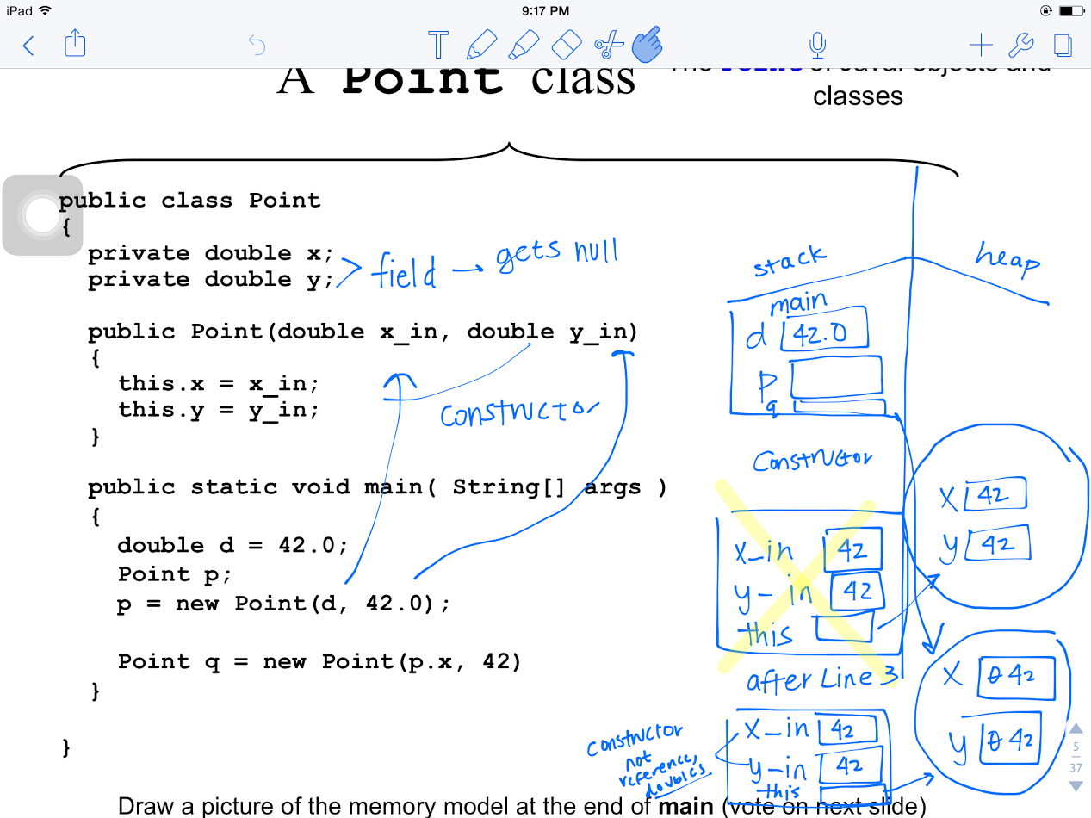

She feels her iPad does a fair job in constraining her from distraction. When she uses her laptop she gets easily distracted. This is because opening a tab on a laptop is much easier than switching apps on a tablet.

The most despicable aspect of midterms is scheduling. Kaila does not like it when she has multiple midterms within 24 hours. It is hard for her to manage her time and do her best to learn.

**2.2 Alex**

Alex is a Senior CS major. His favorite class at UCSD is a History class about Communism in China. Apart from the content, he liked how the class focused on critical thinking rather than learning facts. The professor used films, documentaries and other visuals to bring out the temporal relations of events. Alex does not find it conducive when courses is not well structured.

Alex uses his notebook to take handwritten notes. He avoids using a laptop since that is a source of distraction for him during the class.

Alex likes midterm where there is a possibility of group study. He likes the collaborating aspect of studying and contributing in a group. He does not like courses which entail memorization of facts by each individual student.

**2.3 Aman**

Aman is a sophomore COGS major, CS minor. His favorite class at UCSD is Introduction to Java. He likes it because the class uses an interactive teaching method. The instructor handed out half completed lecture notes in class. The students were expected to fill out these handouts in class while the professor talked about it. Aman finds it hard to learn in class when the only medium of instruction is a powerpoint slideshow. His attention is such classes is short and he easily distracted to social media websites during class.

Aman takes notes on his notebook. Previously, he used to use his MacBook’s OneNote to take notes in class. He switched to paper and pen because he would get distracted while making notes. It also meant he would revise from his MacBook which meant more distraction while revision. Moreover, it made him dependent on the battery of his MacBook.

Aman is a visual learner, he like actively practicing problems to learn. He doesn’t retain well if he reads a textbook.

Aman likes the midterms where problem-solving skills are tested rather than rote learning. He feels he gains much more from these classes few months after they have lapsed. Like Alex, he doesn’t like it when the midterms test memorization. Additionally, he faces difficulty in guessing and prioritizing professors’ thought on what part of material is important from an exam standpoint.

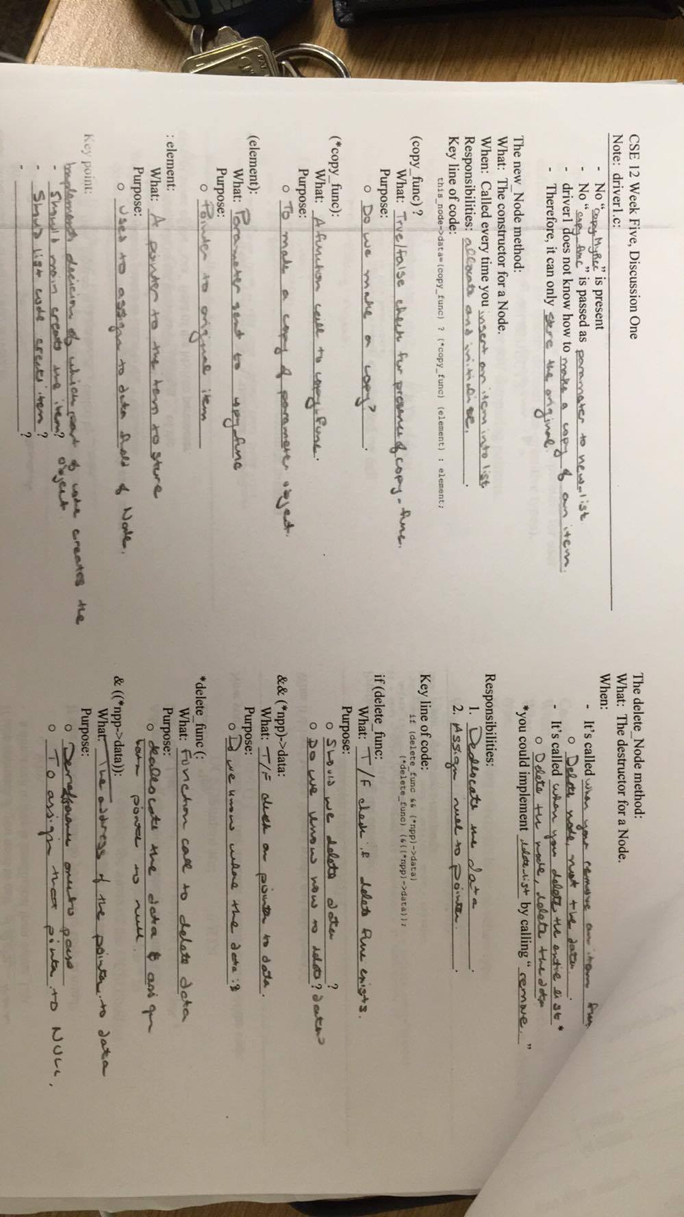  
Half-filled handout for CSE12, UCSD

# **Section 3 – Photos and Captions of Activity**

I wanted to observe a common tool people use throughout UCSD. For the activity, I choose to observe people using Piazza. I asked them to perform following activities

* Read all posts in a course posted by Instructors
* Find their usage and contributions statistics on Piazza
* Preview a post before submitting it to the class

1. Kaila

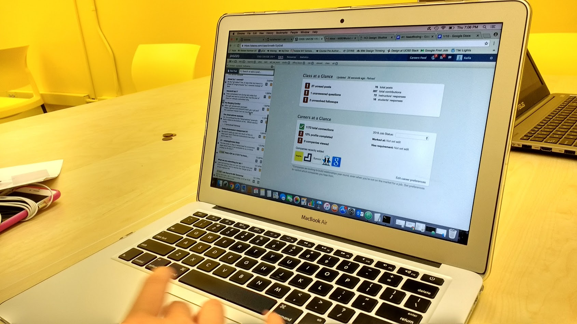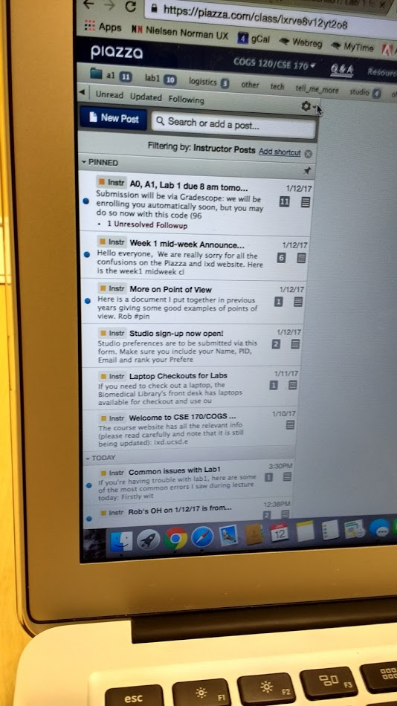

Kaila tried to find all the instructors by looking for  symbols

1. Alex

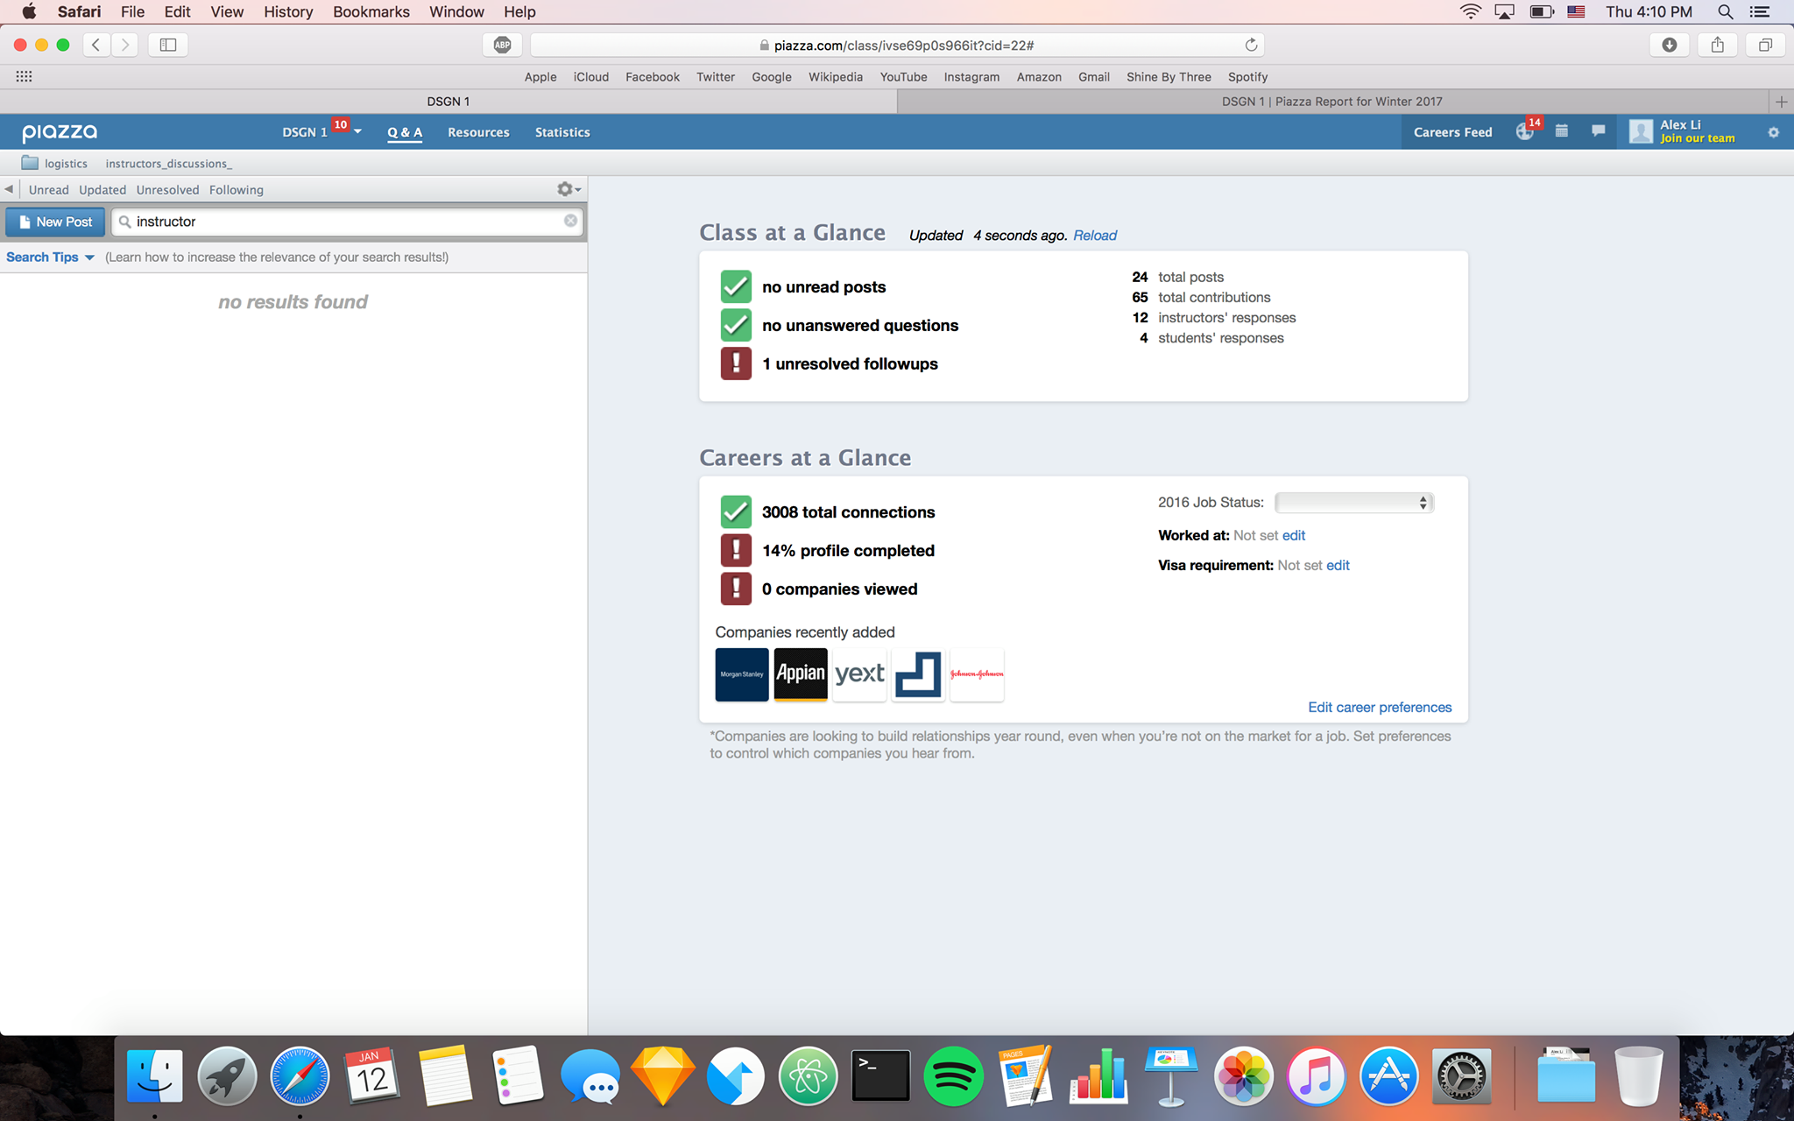

Alex tried to use the search bar on Piazza to find all the posts by instructor. But Piazza doesn’t let you search tags

1. Aman

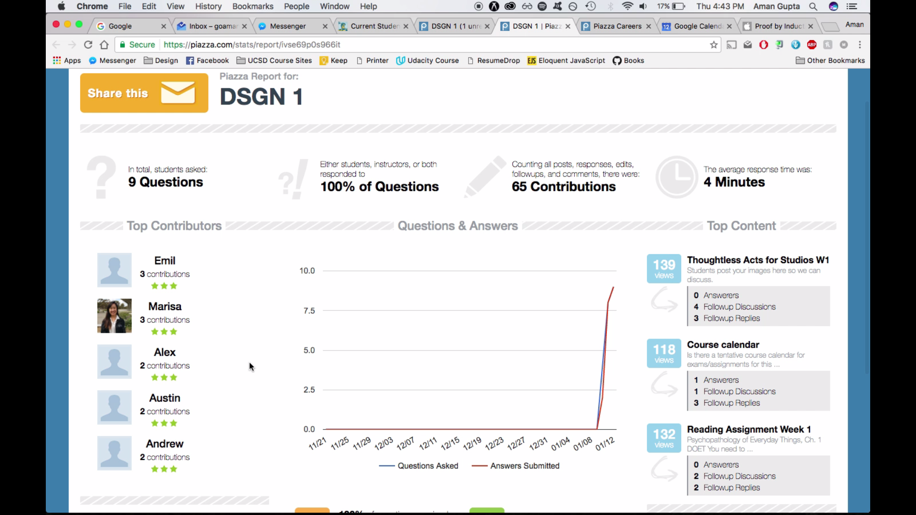

Aman was the **only** one who managed to find the top contributors page. But it took him 2 minutes of clicking all possible places to finally *discover* the  tab on the top

# **Section 4 – User Needs**

1. Students need a way to manage their time and tips for studying effectively
2. Students need a way to gauge what professor considers important in order to prioritize the topics and their effort
3. Students need a way to be more engaged in class lecture and feel part of it
4. Student need a way to prevent them from distraction when using their laptops for taking notes/studying for course
5. Student need a way to visualize information in terms of diagrams, videos, conceptual models to retain information longer
6. Student need a way to prepare effective study guides for midterms
7. Students need an active way to prepare and learn for midterms – beyond rote memorization
8. Students need a way to maximize the number of courses they take which are of interest to them
9. Students need a way to manage their notes across Textbooks, Personal Notes and Lecture Slides
10. Students need a way to approach professors with lesser intimidation
11. Students need a method to focus and absorb information when the only teaching method is a PowerPoint
12. Students need a way to manage stress for overwhelming moments
13. Students need to a way to convey lack of structure and direction in a course
14. Students need a way to find correct strategy for studying different courses
15. Students need a way to leverage group study effectively

**Section 5 – Point of View**

Gaining knowledge is an active process. The learning and teaching methods need to engage students actively by making them part of the process. A failure to do so leads to distraction, loss of time and opportunity to learn.